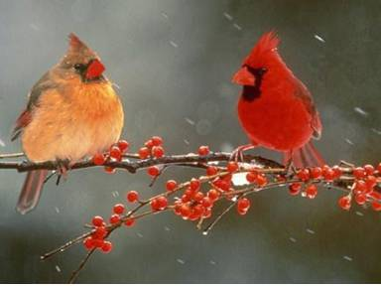Name: ______________________________________ Date: __________________ Per: ____ DUE: _________

Vocabulary - Bird Sleuth – The Cornell Lab of Ornithology

*Using the Cornell Lab of Ornithology Science Glossary - write a sentence using the vocabulary word correctly (relating to BIRDS) and draw a picture that helps to describe the word.

Female and Male Cardinals

**VOCAB WORD SENTENCE PICTURE**

|  |  |  |
| --- | --- | --- |
| 1. Albinism |  |  |
| 2. Arthropods |  |  |
| 3. Behavior |  |  |
| 4. Binomial Nomenclature |  |  |
| 5. Breeding range |  |  |
| 6. Citizen scientist |  |  |
| 7. Classification |  |  |
| 8. Common Name |  |  |
| 9. Diopter Adjustment Ring |  |  |
| 10. Distribution |  |  |
| 11. Evolution |  |  |
| 12. Eyepieces |  |  |
| 13. Field Guide |  |  |
| 14. Field mark |  |  |
| 15. Fledgling |  |  |
| 16. Flight style |  |  |
| 17. Focus wheel |  |  |
| 18. Foraging |  |  |
| 19. Genus |  |  |
| 20. Habitat |  |  |
| 21. Incubation period |  |  |
| 22. Invertebrates |  |  |
| 23. Mnemonics |  |  |
| 24. Migrant |  |  |
| 25. Molt |  |  |
| 26. Nestling |  |  |
| 27. Nonbreeding range |  |  |
| 28. Passerine |  |  |
| 29. Plumage |  |  |
| 30. Range map |  |  |
| 31. Scientific name |  |  |
| 32. Sexual dimorphism |  |  |
| 33. Silhouette |  |  |
| 34. Species |  |  |
| 35. Species account |  |  |
| 36. Taxonomic order |  |  |
| 37. Taxonomy |  |  |
| 38. Wetland |  |  |
| 39. Year-round range |  |  |

